**Altered Brain Activity in Unipolar Depression Revisited using Connectomics**

**Robin FH Cash1,2,** **Veronika I. Müller3,4; Paul B Fitzgerald5, Simon B. Eickhoff3,4,**

**Andrew Zalesky1,2**

1. Melbourne Neuropsychiatry Centre, The University of Melbourne, Victoria 3010
2. Department of Biomedical Engineering, The University of Melbourne, Victoria 3010
3. Institute of Systems Neuroscience, Medical Faculty, Heinrich Heine University Düsseldorf, Düsseldorf, Germany
4. Institute of Neuroscience and Medicine, Brain & Behaviour (INM-7), Research Centre Jülich, Jülich, Germany
5. School of Medicine and Psychology, The Australian National University, Canberra ACT 2601

**Corresponding author**:

Dr. Robin Cash

Email: [robin.cash@unimelb.edu.au](mailto:robin.cash@unimelb.edu.au)

Phone: +61 3 83441929

Melbourne Neuropsychiatry Centre, The University of Melbourne, Victoria 3010

**Content Type:** Analysis

**Short title**: Altered Brain Activity in Unipolar Depression

**Abstract word count**: 150 words

**Manuscript word count**: 3733

*Main text*:

Figures: 6

*Supplementary*:

Figures: 6

**Keywords**: depression, reproducibility, meta-analysis, heterogeneity, MRI, Transcranial Magnetic Stimulation, personalization

**Funding statement**: RFHC is funded by the Australian Research Council (DE200101708) and Brain and Behavior Research Foundation. A.Z. was supported by the Australian National Health and Medical Research Council (NHMRC) Senior Research Fellowship B (ID: 1136649). PBF has received equipment for research from Cervel Neurotech, Medtronic Ltd., MagVenture A/S and Brainsway Ltd. SBE acknowledges funding by the European Union’s Horizon 2020 Research and Innovation Program (grant agreements 945539 (HBP SGA3) and 826421 (VBC), the Deutsche Forschungsgemeinschaft (DFG, Project-ID 431549029 – SFB 1451) and the National Institute of Health (NIH, 2R01-MH074457).

**Data availability statement**: HCP datasets are available for download to anyone agreeing to the open access data use terms (<https://db.humanconnectome.org/>). The clinical data remain subject to privacy and ethical restrictions.

**Abstract**

Over twenty years of neuroimaging experiments into aberrant task-based brain activity in unipolar depression (UD) have failed to reliably delineate a convergent set of anatomical regions. We examined whether study-derived coordinates might delineate a dysfunctional brain network in UD rather than isolated neuroanatomical foci, utilizing data from 57 studies with 99 individual neuroimaging task-based experiments, testing either emotional or cognitive processing(n=1058 UD). We further assessed clinical relevance, by computing optimal network-based personalized targets in 26 individuals who previously received Transcranial Magnetic Stimulation (TMS) for UD. Although coordinates were neuroanatomically heterogeneous, they localized to highly robust distributed brain networks. Importantly, these networks closely recapitulated clinically meaningful and independently derived models of depression circuitry, quantified by spatial correlation(P<0.00002). TMS therapeutic outcome was dependent on how effectively this circuit was targeted(P=0.018). These findings indicate that neuroimaging findings in depression which previously appeared irreconcilable, localize to highly robust and clinically meaningful distributed brain networks.

Unipolar depression (UD) is one of the most common mental health disorders worldwide but remains incompletely understood. Several decades of research have focused on delineating the neural substrates mediating emotional and cognitive impairments in depression, but findings have varied considerably. More concerning, various meta-analyses aimed at distilling these findings have been unable to reliably delineate a convergent set of anatomical regions, producing inconsistent or null findings. Of particular note, a recent meta-analysis examining data derived from >1000 patients across 57 studies and 99 individual neuroimaging experiments demonstrated a lack of significant convergence across these studies and additionally highlighted a lack of consensus across prior meta-analyses1.

The heterogeneity across these prior research findings has been highlighted as an example of the ‘reproducibility crisis’ in neuroimaging2, and further contributes to concerns around the neurobiological, clinical and translational value of neuroimaging findings, which have together spurred on a new field of ‘meta-research’3. Given the significance of this predicament, substantial efforts have been devoted to identifying factors responsible for this lack of reproducibility such as sample size, sampling effects (no patient group is like the other), experimental flexibility (no task or study design is like the other) and analytical flexibility (no analysis pipeline is like the other)1,4-7. Such issues may be exacerbated in the case of psychiatric disorders such as UD, which tend to be associated with high interindividual heterogeneity8.

Conventional meta-analyses which utilize methodologies such as activation likelihood estimation (ALE) provide a powerful means to identify regional neuroanatomical correlates of behavioral impairment. The implicit assumption is that a disorder may be distilled to one, or a set of, predominant neuroanatomical aberrations circumscribed to distinct spatial loci 9. However, it is increasingly evident that neuropathological phenomena do not act in isolation, but are instead interconnected via distributed functional and structural brain circuits 10. Accordingly, localization of psychiatric symptoms, including in the context of depression, has increasingly shifted from a primary focus on individual brain regions, to a focus on distributed brain networks 11. This network-based framework is supported by several lines of evidence, most notably the finding that lesions located across different sites within the same brain network can elicit comparable symptom pathology, demonstrated across a host of neuropsychiatric disorders, including major depression 4,12-14. The connectivity of these lesions can thus be used to delineate a common brain network that is causally involved in symptom expression. Conversely, successful modulation of this disease-related brain circuit using therapeutic deep brain stimulation (DBS) or transcranial magnetic stimulation (TMS) can alleviate symptom expression and potentially lead to clinical response or remission 15-17.

Current meta-analytic paradigms are designed to identify cortical loci consistently associated with abnormalities across multiple independent studies. However, abnormalities may be circumscribed more broadly to brain networks rather than focal loci, motivating network-based meta-analytic approaches (Figure 1A). A circuit-based framework therefore assumes that these sites should occur within the same distributed brain network. Therefore, spatial dispersion of coordinates within such a circuit can be expected and is likely to be amplified across different studies by the fact that scientific research rewards novelty and thus incentivizes unique study designs and tasks. Additional variation may derive from small sample sizes, heterogeneity within psychiatric populations, analytic flexibility, the low signal to noise ratio and indirect nature of the hemodynamic bold signal, and differences in experiment operationalization 18.

Under this framework, we demonstrate that the seemingly irreproducible findings across prior neuroimaging studies of emotional and cognitive processing abnormalities in UD 1, can be unified from a network perspective and delineate robust symptom specific dysfunctional brain networks. Critically, the networks derived from these coordinates closely recapitulate independently derived and clinically meaningful depression circuits. Lastly, we tested the clinical validity of these circuits in an independent cohort of individuals with depression previously treated with TMS. More specifically, using state-of-the-art personalization methodology, we derived circuit-specific optimal TMS targets for each individual and demonstrate that individuals who were serendipitously stimulated closer in proximity to their optimal target had significantly better treatment outcomes. These findings provide a separate line of evidence that depression symptoms and their resolution are closely associated with these brain circuits. We therefore show for the first time, that two decades of neuroanatomically highly heterogeneous findings in major depression can be reconciled from a connectomics perspective and that they localize to highly robust and clinically meaningful distributed brain networks. These findings provide novel and independent support for the notion that the expression and amelioration of depression is related to circuit-level dysfunction.

**results**:

***Coordinate based network localization identifies robust brain network representing emotional and cognitive processing abnormalities in UD***

In contrast to the absence of consistent findings suggested by conventional coordinate-based meta-analyses of neuroimaging studies in UD, our network-based analysis framework (Figure 1A) revealed that previously reported coordinates delineate robust distributed brain networks related to abnormal brain function (i.e., dysfunction) during emotional and cognitive tasks (Figure 2).

While a significant spatial correlation was evident between the emotional and cognitive circuits (r=0.1, p<0.00), the correlation coefficient was modest, indicating relatively distinct cortical architectures for each circuit. The circuit representing emotional processing abnormalities in UD included predominantly the SGC (Brodmann’s Area (BA) 25), pregenual ACC, left dorsolateral prefrontal cortex (BA 9, 46), cingulum (BA 11, 23), and superior frontal gyrus covering the pre-supplementary motor area and BA 8, 9 and 32. Of note, the lateralization to the left DLPFC occurred despite no overall lateralization of constituent coordinates for this network. In contrast, the circuit relating to cognitive processing abnormalities in UD included the cingulum, dorsal anterior cingulate cortex (dACC), insula, medial prefrontal cortex (BA 10), precuneus, hippocampus, fornix and primarily the right DLPFC (Figure 2).

***Relation with subnetworks***

We next sought to parse the distinct characteristics of the neural processing abnormalities contributing to the emotional and cognitive circuits. To this end, the extent of overlap between these two circuits and separate sub-circuits specifically representing hypo-/hyper-activation during cognitive processing or negative and positive affect were calculated and shown as a correlation network (Figure 3; Further detailed in Supplementary Figure 1; Adjacency matrix depicted in Supplementary Figure 2). The behavioral tasks are detailed in Supplementary Table 2B in the original metanalysis1. This analysis demonstrated that the emotional circuit captures neural abnormalities across both positive and negative emotional processing in UD, but most prominently reflects *hyper*active processing in UD during negative affect and to a lesser extent *hypo*activation during processing of both negative and positive affect. It is weakly anticorrelated with *hyper*active processing in MDD during positive affect or during cognitive processing. Interestingly, the spatial correlation between networks relating to abnormalities of negative and positive affect was minimal, aside from a weak negative correlation between hyperactive sites during negative affect and positive affect. The cognitive network captures abnormalities related to both hyper- and hypoactivity during cognitive processing in UD, but there was no significant spatial relation between circuits relating to aberrant hyper- and hypoactivity in UD.

***Coordinate derived UD brain networks recapitulate clinically meaningful depression circuits***

Next, we investigated whether the emotional and cognitive circuits delineated by the present meta-analytic approach might resemble previous network models of depression (Figure 4). The spatial correlation between brain maps representing aberrant emotional and cognitive circuits and the following was computed: (i) The Subgenual Cingulate Cortex (SGC) whole-brain FC map that is closely associated with TMS therapeutic outcomes in depression 19-21, (ii) A depression circuit map that represents the FC of lesions that led to depression in previously healthy individuals 22, and (iii) A recently described ‘convergent depression circuit’ that incorporates the FC of lesion sites resulting in depression as well as the FC and efficacy of TMS cortical and DBS subcortical targets utilized in the treatment of depression 16.

We found that the emotion circuit recapitulates to a significant extent clinically meaningful models of depression circuitry including (i) the SGC FC map (Rho = 0.73, P = 0.00), (ii) a lesion-derived depression circuit (Rho = 0.47, P = 0.00), and (iii) the ‘convergent depression circuit’ (Rho = 0.47, P = 0.00; Figure 4). See Supplementary Figure 3 for correlograms. Significant but weaker correlations were evident between the cognitive brain circuit and SGC FC map (Rho = 0.37, P = 0.00), lesion-derived depression circuit (Rho =0.06, P = 0.00) and ‘convergent depression circuit’ (Rho = 0.23, P = 0.00).

We performed a supplementary analysis examining the relation between circuits using an extensive range of thresholds whereby either the top 1.5, 5, 10, 15, 30, 50, 75% or all voxels of each map were retained prior to correlation and statistical analysis (Supplementary Figure 4). Broadly speaking, the findings indicated higher correlation coefficients across these circuits at more stringent thresholds, suggestive of stronger convergence within a more spatially specific circuit, and an advantage of thresholding out less relevant and weakly implicated voxels which appear to contribute noise. These networks are depicted side by side in Supplementary Figure 5.

***Testing clinical validity: Personalized targets derived from coordinate-based brain networks relate to TMS clinical outcome***

In an independent dataset of patients with depression, we examined whether individuals who serendipitously received stimulation to a left DLPFC target site that was more closely aligned with the emotional dysfunction circuit had better TMS clinical outcomes (Figure 5). We restricted this analysis to the emotional dysfunction circuit as the cognitive dysfunction circuit was heavily lateralized to the right DLPFC. This patient cohort (n=26) had undergone MRI prior to TMS treatment and their clinical outcomes and stimulation coordinates were known. We computed personalized target coordinates based on functional connectivity with the emotional dysfunction circuit, utilizing recently detailed computational methodology23.

Critically, we found that TMS therapeutic outcome was dependent on how effectively this circuit was targeted on a person-specific basis: closer proximity between circuit-derived personalized targets and clinically applied coordinates was associated with better TMS clinical outcomes (R=-0.41, P=0.018, Figure 6A). Moreover, this relation with better clinical outcome remained highly robust and was not driven by parameter tuning. This is illustrated in the characteristic cluster-threshold curve (Figure 6B) 23, which shows that the relation with better clinical outcome remained highly robust across low cluster thresholds, which are optimal for computing personalized circuit-specific TMS targets, before deteriorating at higher thresholds, which lead to larger clusters and non-specific target coordinates that gravitate toward the center of the DLPFC 23. Personalized coordinates are depicted in Supplementary Figure 6.

We additionally examined whether individual-specific circuit-based coordinates could be substituted by a single group-level ‘one-site-fits-all’ target, which would be more readily implemented clinically. However, consistent with our previous work19,24, we also found that there was no significant correlation when personalized coordinates were substituted by a group-level ‘*one-site-fits-all*’ target, namely (i) the ‘optimal’ group target derived by applying cluster methodology to the emotion network seedmap (R=0.15, P=0.77) or (ii) the spatial group-average of optimal personalized stimulation coordinates (R=0.12, P=0.72).

**Discussion**

The present findings indicate that several decades of research findings relating to emotional and cognitive processing abnormalities in UD, which demonstrated no apparent convergence in terms of circumscribed neuroanatomical spatial foci1, reveal highly distinct, biologically plausible aberrant brain circuits when analyzed using a connectomics framework. Notably, the depression circuits derived using this framework closely recapitulate clinically meaningful depression networks that derive from a range of independent clinical datasets, treatment modalities and methodologies. Further corroborating our findings, we demonstrate in an independent neuroimaging and clinical dataset from a cohort previously treated with TMS for depression, that therapeutic outcome was dependent on how effectively the circuit relating to emotional dysfunction was targeted on a person-specific basis. For this purpose, we adapted state-of-the art methodology that enables ‘optimal’ personalized brain stimulation targets to be computed with millimeter precision19,23,25. Together, these findings provide novel support for the notion that the expression and amelioration of depression is related to circuit-level dysfunction. This framework provides a novel and fundamental contribution that helps to address and resolve concerns around the reproducibility of neuroimaging findings in UD.

Considerable concern has surrounded the lack of reproducibility in the field of neuroimaging including, but by no means limited to UD. Meta-analyses aiming to identify spatial convergence across sites of neurobiological abnormalities in the context of emotional and cognitive tasks in UD identified either divergent or null findings, suggesting that prior conclusions from individual studies were either spurious or not generalizable. The present work illustrates that when these findings are reframed from a neural network rather than regional perspective, statistically highly robust brain circuits are uncovered (Figure 2). Dysfunction within this distributed network may lead to symptom or behavioral manifestation, posing a challenge for meta-analyses aiming to localize specific dysfunctional neuroanatomical foci. This represents a significant contribution to the field given that prior meta-analyses have failed to identify reliable abnormalities in UD across either domain. This circuit-based framework overcomes the challenge posed by heterogeneous findings across studies that likely derive from a range of factors denoted earlier including the incentive to utilize novel task and study designs. This perspective underscores the importance of distributed brain circuits in mediating behavioral function.

The circuits derived from the present work capturing emotional and cognitive circuit dysfunction in UD quantitatively and qualitatively closely recapitulate clinically meaningful depression networks (Figure 4, Supplementary Figures 3-5). Firstly, the brain circuit relating to emotional dysfunction demonstrates a significant relation to the recently described lesion-derived depression network 22. In the latter study, the authors demonstrated that despite the spatial heterogeneity of lesion locations associated with depression, these sites mapped to a common connected brain circuit. Further, the emotional dysfunction circuit derived in the present work demonstrates a highly significant relation with a SGC FC map that has demonstrated robust clinical relevance in the treatment of depression. More specifically, the SGC FC map is reliably associated with TMS response, whereby therapeutic outcomes to TMS relate to the connectivity of the stimulation target with this circuit 19-21. Our circuit map also bears close resemblance to the recently proposed ‘convergent depression circuit’ 16, which captures the connectivity of lesion sites associated with depression, as well as the connectivity and efficacy of TMS and DBS target sites (Figure 4). Interestingly, the relation to these circuits is much stronger for the emotional dysfunction brain circuit map compared to the cognitive dysfunction map. There are a range of intriguing possibilities that might account for this stronger relation, although each of these remain speculative.

The regions implicated in the circuits derived here are reminiscent of those implicated in prior neuroimaging and histological research, although it is worth highlighting again that these regions could not be captured by prior meta-analyses designed to identify spatial convergence. The emotional dysfunction circuit includes most prominently the pregenual and SGC, DLPFC, insula and pre-supplementary motor area (pre-SMA). The SGC has been frequently implicated in both negative affect and treatment response in depression, and is the most common DBS target site for treatment resistant depression 26. Dysfunction within the DLPFC has been proposed to relate to impaired top-down regulation of negative affect 27,28. The spatial distribution of regions within the DLPFC most implicated here closely resembles the pattern of DLPFC brain stimulation targets associated with better antidepressant response as defined by FC with the SGC23 (Figure 4). The mPFC is thought to be involved in the monitoring and regulation of affective state, also providing one link between dorsolateral prefrontal and subcortical regions 27,29. The pre-SMA is connected with lateral prefrontal cortices, but not motor cortex, and is associated with emotion appraisal and expression 29. The insula is involved in both emotional and cognitive processes, and functional and structural alterations in the insula are frequently observed in depression and have been associated with illness severity and duration 30. Together these regions provide a highly plausible circuit in which impaired function could lead to emotional dysfunction. The circuit relating to cognitive abnormalities in UD includes predominantly the hippocampus, dACC, DLPFC, insula, and cingulum extending from BA10 posteriorly to the precuneus and fornix. These regions likewise provide a highly plausible circuit for impaired cognitive processing in UD. Interestingly, this circuit includes a dorsomedial PFC region previously termed the ‘dorsal nexus’ 31 (Figure 2) to describe its increased connectivity in depression across the cognitive, affective and default mode networks in resting state fMRI. This site of apparent ‘hotwiring’ across networks in depression provided the rationale for selection of the dorsomedial prefrontal cortex as an alternative TMS target, which has proved to be successful 32,33.

Together the sites implicated across these emotional and cognitive dysfunction circuits also capture those described in an early network model of neurobiological dysfunction in depression by Mayberg and colleagues (1997), which integrated sites related to mood, cognitive and vegetative-somatic dysfunction in depression. Curiously, the subcortical components of the cognitive dysfunction map also provide a close match to the Papez circuit, proposed in 1937, for the anatomical basis of emotional processing. The Papez circuit has gained broad experimental support from a broad range of anatomic, lesion and stimulation studies in animals and human patients, and sites within this circuit were targeted by psychosurgical lesions in the early treatment of depression for review see 34. The neuroanatomical composition of these circuits is further corroborated by histological studies which have implicated microscopic changes at the cellular level in these regions in postmortem brain tissue for review see 35.

Interestingly, the sites of the DLPFC most strongly implicated in the cognitive and emotional circuits are spatially complementary and show relatively little overlap (Figure 2). A further point of interest is the left-lateralization at the DLPFC in the emotion dysfunction network. Interestingly, in terms of constituent coordinates of the emotion dysfunction circuit, there was no bias towards the left hemisphere. Nonetheless, the left DLPFC lateralization observed here is comparable to that independently observed by Padmanabhan and colleagues in their lesion-based network of depression (2019). Of note, TMS is conventionally delivered to the left DLPFC based on the notion that excitatory stimulation could normalize hypoactivity in this region, although this specific modus operandi has received waning experimental support since it was first proposed for review see 36. Curiously, the circuit relating to cognitive abnormalities in UD displayed strong lateralization towards the right DLPFC.

As noted earlier, the circuits relating to cognitive and emotional dysfunction in UD demonstrate little spatial relation suggesting that they are relatively independent and domain specific (Figure 2, Supplementary Figure 3-4). Whether these circuits might be transdiagnostic and relevant to emotional and cognitive dysfunction in other psychiatric disorders would be of particular interest as prior work has suggested frequently shared genetic and network abnormalities across psychiatric disorders 37. The distinction between these circuits is in agreement with the finding that emotional and cognitive symptoms resolve at different rates following treatment, with residual cognitive dysfunction common during remission 38. It is also noteworthy that there is very little relation between circuits mediating negative and positive affect (Figure 3, Supplementary Figure 2). The apparent distinction between these circuits provides potential experimental support for the recent proposal by Figee and Mayberg 39, that individuals with depression might require differential modulation of distinct circuits relating to diminished positive or excessive negative affect, according to their personal symptom profile.

While some analyses have implicated a single overarching depression network16,22, these findings should be interpreted in the context of the study aims and the granularity of the available clinical and neuroimaging data. For example, using an ICA based approach to network definition, one study concluded that no psychiatric disorder could be defined by a single aberrant brain network, nor was any dysfunctional brain network unique to a given psychiatric disorder. Other research has proposed the existence of separate circuits mediating dysphoria, anhedonia, rumination and cognitive symptoms 40, or the existence of separate circuits mediating dysphoric and anxiosomatic symptoms 41. In any case, the present findings provide a novel evidence base to explore the therapeutic effects of targeting domain and circuit specific abnormalities in UD.

Our final analysis demonstrates in an independent dataset comprising a cohort of individuals previously treated with TMS for depression, that therapeutic outcome was dependent on how effectively the emotional circuit was targeted (Figure 6). This analysis was performed on the emotional dysfunction circuit as the cognitive dysfunction circuit was strongly lateralized to the right DLPFC. For this purpose, we adapted state-of-the art methodology that enables ‘optimal’ personalized brain stimulation targets to be computed with millimeter precision 23. We applied the emotional dysfunction circuit as a weighted seedmap to each image of an individual’s resting state MRI data to first compute the timeseries of this circuit and then its connectivity across the spatial extent of the DLPFC 23,25. We were then able to identify the individual-specific optimal DLPFC stimulation site for targeting this circuit. This analysis demonstrated that individuals who serendipitously received TMS closer to their optimal target had a significantly better therapeutic response. This analysis provides evidence that depression symptom amelioration is associated with how successfully the dysfunctional emotion network derived from the present work is targeted, providing an independent demonstration of clinical validity. It is worth noting that these findings are not intended to suggest that the present circuit replace the SGC FC circuit for the computation of personalized TMS target sites. The present relation, while notable and statistically significant (R = -0.41) is weaker than the relation we previously observed for personalized targets identified using the SGC FC circuit (R = -0.6) 19. The present findings are instead interpreted as demonstrating the genuine clinical relation between the extent to which this circuit is successfully targeted and clinical depression outcomes, while the SGC FC circuit remains a superior option for prospective clinical targeting. Interestingly, the present targets align more with the posterior target recently proposed to relate to anxiosomatic symptoms41 (Supplementary Figure 6), and our ongoing research indicates that there may not be just one single optimal DLPFC target for each individual. In line with our previous work 19,24, these data also indicated that this relation only held when individual-specific circuit-based coordinates were computed, whereas there was no significant relation when these were substituted by a group-level *‘one-site-fits-all’* target.

Of note, this relation utilizing circuit-derived targets provides novel and independent support of the notion that TMS outcomes are mediated by targeting dysfunctional brain circuits, rather than individual regions. This may suggest that while the SGC seedmap approach has been previously implemented primarily to increase the signal to noise ratio of the SGC region23,25, it may also be that the broader network is actually the appropriate target.

There are a few potential limitations in this work. Firstly, the coordinates included here are derived only from studies utilizing whole-brain, rather than ROI-based analyses1. This approach follows best practices and is intended to avoid selective and potentially biased analyses that could exaggerate the role of particular brain regions and their connections42.

Secondly, there may be disadvantages of utilizing a normative connectome data when the goal is to uncover aberrant behavioral circuits in a patient population. However, the HCP provides a large openly available source of very high-quality data, the equivalent of which does not currently exist for UD. There are many precedents for utilizing normative data in this context, and prior work indicates that the impact of utilizing normative or patient neuroimaging data for this process is relatively minor43. Moreover, the aim of the present work is not to determine alterations in the strength of FC, but rather to delineate interconnected regions or circuits that appear dysfunctional in UD. We validated the key findings in a patient sample and additional demonstrated close convergence with depression circuits derived from independent work as well as clinical relevance.

Thirdly, there may be differences in brain connectivity during task compared to rest. Resting-state data therefore provides only a best estimate of the circuits to which constituent coordinates belong. Fortunately, prior work suggests that task derived coactivation networks are strikingly similar to resting state networks 44, and that while changes in FC may occur during task performance, they are relatively minor 45. Accordingly, the term ‘intrinsic connectivity network’ 46 has been coined to denote the finding that resting state FC can characterize an ‘intrinsic’ functional network architecture that is present across many (or all) brain states 47,48, much like structural connectivity 45.

Lastly, there can be differing views on what constitutes a brain network. On the basis of multifold evidence presented in this work, we interpret the present findings as likely to represent polysynaptic circuits relating to emotional and cognitive dysfunction in UD. This is in part because these circuits closely recapitulate three independently derived depression circuits that have been related to clinical severity (lesion based) and treatment response (TMS, DBS) (Figure 4). Moreover, retrospective analysis in independent patient data indicated that alleviation of depression following TMS was significantly related to successful targeting of the emotional dysfunction circuit and on a person-specific basis (Figure 6). The interpretation of these findings aligns with previous work demonstrating that comparable polysynaptic brain networks could be delineated according to brain activation or resting state functional connectivity44, and is in agreement with literature using related methodologies4,12,14,16.

In conclusion, the present findings provide comprehensive evidence that neuroimaging findings which previous appeared irreconcilable, can be reinterpreted from a connectomics framework to reveal biologically plausible and clinically meaningful dysfunctional brain circuits in depression. These networks closely recapitulate independently derived models of depression circuitry that stem from a range of independent clinical datasets, treatment modalities and methodologies, and showed a robust relation to depression treatment outcome in an independent dataset. Together these findings support the notion that the expression and amelioration of depression is related to distributed circuit-level dysfunction. This work additionally provides a novel framework that may help to resolve concerns around the reproducibility of neuroimaging findings in UD and more broadly.

**Acknowledgements**

We thank Shan Siddiqi for providing the convergent and lesion circuits. We thank all participants, nurses and staff involved in the collection of clinical data. We thank all who contributed to the original experiments from which the present coordinates are derived and those involved in the Human Connectome Project.

**ONLINE Methods**:

***Coordinate data***:

We utilized data from a recent best-practices ALE meta-analysis which deemed prior task-based neuroimaging data in UD to be incongruous 1. This dataset comprised 57 studies with 99 individual neuroimaging experiments with a total of 1058 patients. Of these studies, 34 tested cognitive and 65 tested emotional processing. Each included experiment statistically contrasted neural activation between an adult (>18 years) UD group and a control group of healthy individuals. Abnormal brain function (i.e. dysfunction) was thus defined by hypo- or hyperactivation when engaged in a task requiring either emotional or cognitive processing according to the metanalysis on which the present work is based1. The specifics of each task, and their categorization are detailed in Supplementary Table 2B in the original metanalysis.Inclusion and exclusion criteria are detailed elsewhere1. Only experiments utilizing whole brain group analyses were included; those utilizing ROI analyses were excluded. Data were processed in MNI space. Talairach coordinates were converted into MNI space using the tal2mni function provided within Statistical Parametric Mapping software (SPM12, http://www.fil.ion.ucl.ac.uk/spm/software/spm12/). Any coordinate located outside of gray matter according to the FSL MNI 152 2mm brain template, including midline coordinates centered at x=0, were excluded due to ambiguity and potential partial volume effects.

***Normative human connectome data*** ***and preprocessing:***

Resting state functional MRI (rfMRI) images from 100 healthy adults participating in the Human Connectome Project (HCP) were analyzed 49,50. Demographics were reported as: 52 Female, 48 Male, aged (mean±SD): 29±4, with ethnicity noted as: ‘American Indian/Alaskan Native’ (n=1), ‘Asian/Native Hawaiian/Other Pacific Islander’ (n=5), ‘Black or African American’ (n=15), ‘More than one' (n=3), 'Unknown or Not Reported' (n=3), 'White' (n=73); amongst these, 10 individuals were noted as 'Hispanic/Latino'. HCP datasets are available for download to anyone agreeing to the open access data use terms (https://db.humanconnectome.org/). Data collection was performed in a customized Siemens Skyra 3T scanner according to the following parameters: gradient-echo EPI sequence, 720ms TR, 33.1ms TE, 52-degree flip angle, 208×180mm FOV, 104×90 matrix, 2.0mm slice thickness, 72 slices, 2.0mm isotropic voxels, 8 multiband factor and 0.58ms echo spacing. In this study, we analyzed data from the first two fMRI sessions, acquired consecutively on the first day of scanning. Each of the two data acquisition sessions comprised 14m33s runs (right-to-left and left-to-right phase encodings, 1200 volumes each), with eyes open with relaxed fixation on a projected bright cross-hair on a dark background (and presented in a darkened room). These two 14m33s runs per day were temporally concatenated (following preprocessing, described next) to result in 29 minutes of data and 2400 datapoints per concatenated scan. To minimize temporal discontinuity, the mean was removed from each time series prior to concatenation. Concatenation of the two different phase-encoded data (right to left, left to right) ensured that any potential (but likely trivial) effect of phase encoding on gradient direction was counterbalanced by the opposing phase encoding51. Importantly, aside from the direction of acquisition (right to left, left to right), scanning parameters were identical across sessions, and these sessions were performed on the same day50. Concatenation improves the reproducibility of resting state functional connectivity measures, as the test–retest reliability of these measures scales upward with increasing data and number of sessions52-56.

Acquired images were preprocessed by the HCP according to the HCP functional preprocessing pipeline, which involves: 1) spatial and gradient distortion corrections, 2) correction of head movement, 3) intensity normalization 4) single spline re-sampling of EPI frames into 2mm isotropic MNI space and 5) HCP’s FIX+ICA pipeline for the removal of temporal artefacts. Refer to 49,50 for further details on HCP resting-state functional MRI acquisition and preprocessing.

In addition to the HCP minimal preprocessing, band pass temporal filtering (BPTF; 0.01-0.1Hz) was employed. Analyses were performed on minimally smoothed data (4mm FWHM) to reduce loss of spatial information and spurious shifts in boundaries between gray and white matter 57.

***Computation of connectivity and brain networks***:

Whole brain FC was computed for each coordinate as illustrated in Figure 1B. Spherical seeds (4 mm radius) were centered at each reported coordinate. Whole brain FC maps were then computed by correlating the mean time series from this sphere with time series for every voxel comprising a grey matter mask (FSL MNI 152 2mm brain template). The FC maps from all coordinates in a given condition were summed voxel-wise and the summand was divided by the total number of constituent coordinates to generate a condition-specific FC map. This procedure was repeated for 100 individuals and the resulting FC maps were averaged to generate a single normative FC map for each condition. As this was intended to represent a normative map, subject to the HCP demographics reported above, the potential influence of gender, age or ethnicity was not considered.

Next, the mean FC map for each condition (e.g. ‘emotional dysfunction’) was subjected to statistical testing (Figure 1C). This procedure mimicked that described above, except that FC maps were derived from randomly generated (rather than real) coordinates. The same sample of 100 individuals from the HCP was used to compute FC maps. For a given condition, the number of contributing coordinates (***n*** coordinates) was also held identical across observed (real) and randomly generated (null) FC maps. This procedure was repeated 1000 times per condition, to generate 1000 group-average FC maps, each derived from ***n*** coordinates. We used this empirical null distribution to test the alternative hypothesis that the observed coordinates were constrained to specific functional networks. To this end, a z-score map was computed by subtracting the mean of the 1000 null samples from the observed FC map and dividing the result by the standard deviation across the 1000 null samples. This was performed independently for each grey matter voxel and condition, yielding a z-score map for each condition. These z-scored condition-specific brain network maps are referred to as ‘*brain maps*’. In simpler terms, these brain maps represent the connectivity of dysfunctional brain regions in unipolar depression relating to a particular task domain (emotion or cognition), and every voxel value corresponds to the level of deviation from what would be expected by chance (as defined by the null distribution).

***Relation between brain maps:***

In order to better understand the etiology of any putative networks capturing emotional and cognitive processing abnormalities, we generated brain maps derived solely from constituent subtasks (e.g., positive vs. negative affect) and relating to sites of aberrant hypo- or hyperactivity in UD using the same methodology. The tasks are detailed in Supplementary Table 2B in the original metanalysis1. For the emotion domain, these tasks refer to those testing (i) positive affect (e.g. fMRI response to viewing or processing ‘happy’ or positive emotional stimuli), (ii) negative affect (e.g. fMRI response to viewing or processing ‘sad’ or negative emotional stimuli), (iii) unspecified affect (i.e. when there was no clear designation as positive or negative affect). The designation of positive, negative and unspecified affect is derived from the original metanalysis1. In each category there is a contrast of UD > healthy controls and healthy controls > UD. For the cognitive domain, ‘subtasks’ were derived from (i) task>control, (ii) task>baseline and (iii) task difficulty. We anticipated that FC maps and statistical tests based on a low number coordinates might not yield reliable and robust outcomes. Accordingly, availability of 20 coordinates per condition was designated as a minimum number of datapoints to reliably proceed with this analysis. The second two task categories in the cognitive domain did not meet this minimum criterion, namely: (i) cognitive tasks, in which coordinates were derived from a comparison of task>baseline: HC>UD n = 4, UD>HC n= 26 consequently excluded as the matched condition; (ii) cognitive tasks examining “task difficulty”: n = 3 (note this category was based on a “group difference” and no contrast of HC vs. UD was specified). We then computed the spatial correlation between these networks using Spearman’s correlation. The number of coordinates per condition is denoted in Supplementary Figure 1.

Statistical significance was computed for each two-tailed brain map x brain map correlation, with an alpha value of 0.001 that was Bonferroni corrected for multiple comparisons (45 comparisons comprising the upper triangle of a 10x10 adjacency matrix with emotional and cognitive dysfunction networks and 8 sub-networks), resulting in a corrected alpha value of 0.001/45 = 0.00002. Statistical significance was also tested using a refined approach where we first generated a null-distribution of R-values to reflect the probability of achieving a given spatial correlation for the brain map of interest. Beginning with one observed brain map (BM1), 1000 null condition brain maps were generated (BM1-Null-1:1000), each derived from an identical number of coordinates, but using randomly generated rather than observed coordinates. Next, the spatial correlation between each of these null brain maps (BM1-Null-1:1000) and BM2 was computed, generating a distribution of 1000 spatial correlation coefficients. The p-value for the spatial correlation between BM1 and BM2 was then estimated as the proportion of these 1000 correlation coefficients exceeding or equaling the observed correlation between BM1 and BM2. An alpha value of 0.001 was employed. This procedure generates a unique null-distribution of spatial-correlation values for each brain map, resulting in an asymmetric matrix of p-values, while the spatial correlation between two brain maps remains unaffected. Therefore, the alpha value was Bonferroni corrected (0.001/90 = 0.00001; 90 comparisons arise from a 10x10 adjacency matrix when autocorrelations are discarded).

***Convergence and comparison to previous network models of depression:***

The relation between any depression circuit delineated here and previous network models of depression was also tested. Spatial similarity between brain maps was computed using Spearman’s correlation. The spatial correlation between brain maps representing aberrant emotional and cognitive circuits and the following was computed: (i) The Subgenual Cingulate Cortex (SGC) whole-brain FC map that is closely associated with TMS therapeutic outcomes in depression 19-21, (ii) A depression circuit map that represents the FC of lesions that led to depression in previously healthy individuals 22, and (iii) A recently described ‘convergent depression circuit’ that incorporates the FC of lesion sites resulting in depression as well as the FC and efficacy of TMS cortical and DBS subcortical targets utilized in the treatment of depression 16. TMS sites that improve depression are understood to be anticorrelated to DBS sites that improve depression58,59 or lesion sites associated with lower risk of depression16,22. On this basis, the lesion-derived and convergent depression circuit were inverted (map multiplied by -1) for the assessment of spatial correlation16. This approach is consistent with that implemented in related research 16,58.

The spatial correlation between these circuits and resulting p-values were computed as follows. Weak connections are less certain to contribute to a circuit and may represent noise 60. Thus, correlations were performed on whole-brain maps thresholded at an absolute z-score of 3 (i.e. |z| > 3). Voxels with a z-score below this threshold were not included as data points in the correlation. Because thresholding at z=3 gave a slightly different number of voxels for each brain map, a consensus number (2473) of the most significant voxels (absolute z-value) was retained across each brain map, corresponding to approximately the top 1.5% of voxels. To ensure that the correlation was not biased by the number of voxels intersecting across thresholded brain maps, an asymmetric between-network correlation matrix was constructed. This involved thresholding only the first brain map in a pair, whilst the second brain map was held unthresholded. This procedure is optimal because it ensured that all thresholded voxels from the first brain map were available in the second brain map for the correlation computation, rather than only a partial overlap which would introduce variation in the data available to assess the correlation. This procedure was repeated across each row of brain maps in the correlation matrix, with the brain map denoted in a given row always thresholded and the brain maps in columns unthresholded. For comparison, correlations were also computed using non-thresholded brain maps.

The significance of correlations was first tested according to a p-value of 0.001. To estimate p-values, we employed the statistical procedure described above to compute the probability that the previously derived correlations would arise by chance. In short, the first brain map in a pair was correlated with 1000 FC maps, derived from the random coordinates computed earlier, to generate a distribution of 1000 correlation coefficients under the null hypothesis. The observed correlation coefficient was then compared to this empirical null distribution to generate a p-value. Given that this statistical procedure generates an asymmetric 5x5 adjacency matrix, the alpha value was Bonferroni corrected (0.001/20 = 0.00005). For completeness, correlations were also computed when only the aberrant emotion and cognition maps were thresholded at an absolute z score ≥ 3 (Bonferroni corrected alpha value of 0.001/10 = 0.0001, arising from the upper triangle of a 5x5 adjacency matrix). In addition, we performed a supplementary analysis using a range of thresholds whereby either the top 1.5, 5, 10, 15, 30, 50, 75% or all voxels of each map were retained prior to correlation and statistical analysis.

***Clinical Relation:***

The relation between the circuit maps derived from this work and clinical outcome was examined in a cohort of twenty-six individuals with depression (11 Female, 15 Male, 44±14 years, ethnicity data unavailable) who previously underwent rfMRI prior to and following TMS, as part of a clinical trial (ACTRN12610001071011). Participants provided written consent and the protocol was approved by the Alfred Hospital, Monash and Swinburne University Research Ethics Boards (Australia), and conducted according to the principles expressed in the Declaration of Helsinki. Treatment comprised three weeks of daily (5 days/week, M-F) 10Hz TMS, targeted to the left DLPFC using a scalp-based heuristic (F3 beam method). Clinically applied stimulation sites were recorded for each individual and mapped to Montreal Neurological Space (MNI) coordinates. Clinically applied cortical coordinates were defined as the cortical coordinate closest to the scalp position at which TMS was clinically applied. Outcomes of the trial and rfMRI pre-processing is detailed elsewhere61,62.

Personalization methodology23 was applied to the 13:20 minutes of rfMRI data from each individual to derive circuit-specific individualized optimal TMS target sites. This approach was implemented for the emotional dysfunction network, but not the cognitive network which had poor spatial coverage across the left DLPFC. To compute personalized coordinates, we utilized the recently detailed seedmap and cluster-based methodologies 25,63. The seedmap approach is analogous to computing the timeseries from a binarized network or ROI, except that each voxel in the circuit map has a weighted rather than binary value, as illustrated in Figure 1. The circuit-specific timeseries for each individual was thus computed by multiplying their 4D rfMRI data by the z-scored brain map; the timeseries was derived from the sum of each frame. As per previous work, the left DLPFC was masked out to avoid potentially biasing coordinate targets in this region 63,64. Next, FC was computed between the circuit-timeseries and each voxel in the DLPFC to generate a personalized FC map across the spatial extent of the DLPFC. Subsequently, cluster-based methodology was applied to identify the ‘optimal’ DLPFC target site. Based on the high similarity between the emotional map and SGC-FC map, we identified the optimal DLPFC target site as that which FC was most negative. Contiguous clusters of DLPFC voxels at which connectivity was most anti-correlated with this circuit were identified. The center-of-gravity of the largest such cluster was defined as the target coordinate. Clusters were delineated among the top 2.5% most anti-correlated DLPFC voxels, based on our previous work 19,23,24. Clusters were defined among the supra-threshold voxels based on standard 26-voxel neighborhoods.

Proximity between clinically applied and personalized targets was measured using Euclidean distance and correlated with the percentage improvement in Montgomery-Asberg depression rating scale (MADRS) score assessed at three weeks following the first treatment session, as illustrated in Figure 5. To ensure that the relation between clinical outcome and distance to the circuit-derived personalized target was robust and not driven by parameter tuning, a cluster-threshold was generated. For this purpose, personalized targets were identified in an identical manner to that described above, except that the cluster threshold was varied between 0.5 and 50%. This means that after ranking the voxels in the DLPFC in order of negative FC with the emotional dysfunction network, only the top 0.5 to 50% of most negative voxels are retained, before clustering. Low cluster thresholds are optimal for computing personalized circuit-specific TMS targets, whereas higher thresholds lead to larger clusters and non-specific target coordinates that gravitate toward the center of the DLPFC 23,24. This analysis was utilized firstly to ensure that any relation observed in the main analysis above at a cluster threshold of 2.5% was not spurious, and secondly to assess whether this relation was dependent on target coordinates that were highly specific to the person and circuit, or whether they could instead be replaced by less person and circuit-specific DLPFC targets derived at higher cluster thresholds.

To ascertain whether personalized coordinates could be replaced by a more readily implemented group-level ‘*one-site-fits-all*’ target, we computed the above relation for proximity between clinically applied and two potential group-level targets. The latter were derived from the emotion network seedmap, namely the (i) ‘optimal’ group target derived by applying cluster methodology to the emotion network seedmap and (ii) the spatial group-average of optimal personalized stimulation coordinates, each of which was computed using the aforementioned a priori cluster threshold of 2.5%. Covariates such as sex and age were not taken into consideration during the determination of optimal coordinates or the relation between distance and treatment response.

Analyses were performed using Matlab version R2017a (Mathworks Inc., Natick, MA, USA) and FSL version v5.0.10 65. Brain renderings were generated using BrainNet Viewer version 1.63 66.

**Code availability statement**

Code is available on request, although not for commercial applications.

**FIGURES**

***Figure 1: Overview.* (A)**The coordinates (left) represent abnormalities in neural processing in UD during a cognitive task 1. Conventional metanalytic approaches consider these to be spatially disparate and an association between these regions would not be detected. However, while these coordinates are spatially distinct, they may be highly interconnected and may localize to a distributed dysfunctional symptom-specific brain network or circuit in UD. **(B)** For each available coordinate, a functional connectivity map was generated. These were summed, and the summand was divided by the total number of constituent coordinates to generate a condition-specific FC map. This procedure was repeated for 100 individuals to generate a normative FC map for each condition. **(C)** For the purposes of statistical testing, 1000 FC maps were generated using an equivalent procedure, but with each map generated using the same number of randomly generated coordinates. The mean of these 1000 FC maps was subtracted from the observed FC map and result divided by the standard deviation across the 1000 FC maps to derive a whole-brain z-score map.

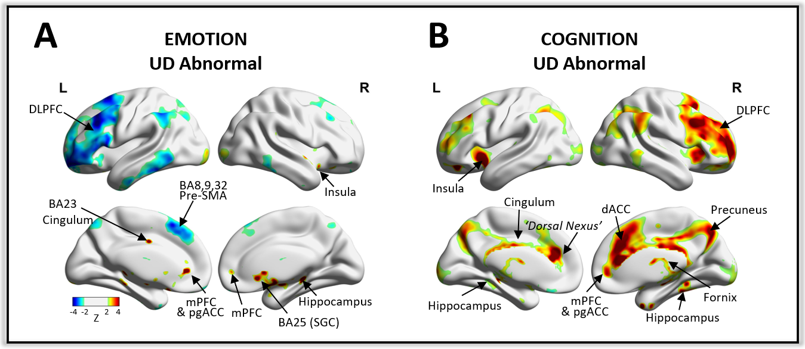

***Figure 2: Brain networks representing (A) emotional and (B) cognitive processing abnormalities in UD***. The circuit related to emotional dysfunction includes regions such as the DLPFC, SGC and pregenual ACC. The circuit relating to cognitive processing abnormalities in UD includes the DLPFC and regions extending posteriorly from the mPFC including the dACC, cingulum, precuneus, insula and hippocampus. A region previously identified as having excessive connectivity in depression, termed the ‘dorsal nexus’ 31, is indicated for the dysfunctional cognition circuit. Full brain maps are provided in Supplementary Information. Here, weak connections (Z<|2|) are thresholded out to highlight key regions within these distributed networks.

***Figure 3: Relation across different brain network maps.*** Correlation networks characterizing the relation between the emotional and cognitive circuits and sub-circuits derived specifically from positive and negative emotional processing abnormalities, and hypo and hyperactivity during those cognitive and emotional tasks. Positive spatial correlations are denoted by edges in shades of red, negative correlations are depicted in shades of blue; increasing correlation strength is denoted by increasing thickness of the edge. Node size represents node degree (i.e. the number of significant correlations between different circuits). Of note, the circuit relating to aberrant emotional function in UD is most strongly associated with negative affect and there is little relation between circuits related to sites of aberrant function during negative and positive affect. Brain images are individually thresholded to optimize display and avoid saturation. To aid presentation, weak edges (R<|0.2|) are omitted. For unthresholded images and correlation coefficients refer to Supplementary Information.

***Figure 4: Convergence and comparison to previous network models of depression.*** The brain maps derived from the present data and connectivity-based framework closely recapitulate depression circuits derived from independent datasets and methodologies. Edge color and thickness both represent spatial similarity, computed as Pearson’s correlation. The brain network capturing emotional circuit dysfunction demonstrated a high statistically significant relation to the lesion-derived depression network, SGC FC map and ‘convergent depression circuit’. For the brain network capturing cognitive circuit dysfunction, the association with other networks was weaker, but still significant. Note that the convergent depression circuit 16 and lesion depression circuit 22 are depicted as presented in the original papers for easier reference.

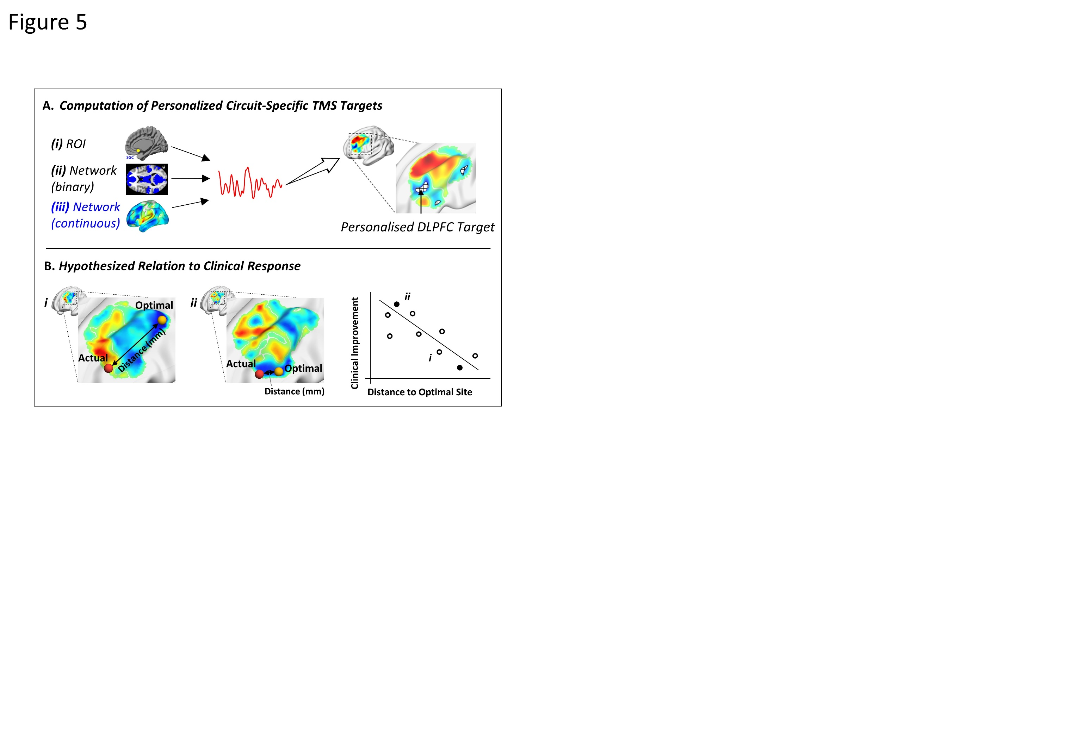

***Figure 5: The relation between TMS*** ***circuit-targeting and clinical response. (A) Computation of personalized circuit-specific TMS targets.*** Circuit-specific timeseries were computed for the continuous z-scored circuit map. This approach is akin to computing the timeseries from a binarized network or ROI, except that the circuit map is continuously weighted and not binarized. Each voxel is weighted by the probability (or extent) that it contributes to the network, indicated by its voxel-specific score, also enabling the computation of the timeseries to be impacted by positively and negatively correlated voxels. This approach also avoids arbitrary binarization thresholds. The approach is also analogous to computing the timeseries from a continuously weighted seedmap 23,25, except that the purpose is not to increase the signal to noise ratio, but rather to generate a circuit-level timeseries. Next the FC between the circuit-derived timeseries and every voxel across the DLPFC is computed. Finally, a cluster-based approach is used to identify the circuit-specific personalized DLPFC target. ***(B)*** ***Hypothesized relation to clinical response***. We anticipated that closer proximity between clinically applied and personalized circuit-specific targets would lead to improved treatment response 19. This is a cartoon example, but DLPFC maps i-ii stem from individuals in the sample and their relative position on the distance-response graph is accurately represented.

***Figure 6. Efficacy of circuit-specific targeting predicts TMS clinical success.*** **(A)** In a cohort of twenty-six individuals with depression who previously received TMS targeted to the left DLPFC using the F3 beam scalp-based heuristic 67, closer proximity between actual and circuit-specific TMS targets associated with better clinical outcome (R=-0.41; P=0.02; Pearson correlation; Cluster Threshold 2.5%). Coordinates were optimized to target the aberrant emotion circuit in UD, rather than the cognitive network which had no statistically significant sites at the left DLPFC. Each datapoint represents one individual; the shaded region indicates the 95% confidence interval. **(B)** This cluster threshold curve indicates that the relation is highly robust and specific to low thresholds that identify personalized targets rather than high thresholds that identify generic targets. This is indicated by varying a key parameter termed ‘cluster threshold’.

***Supplementary Figures:***

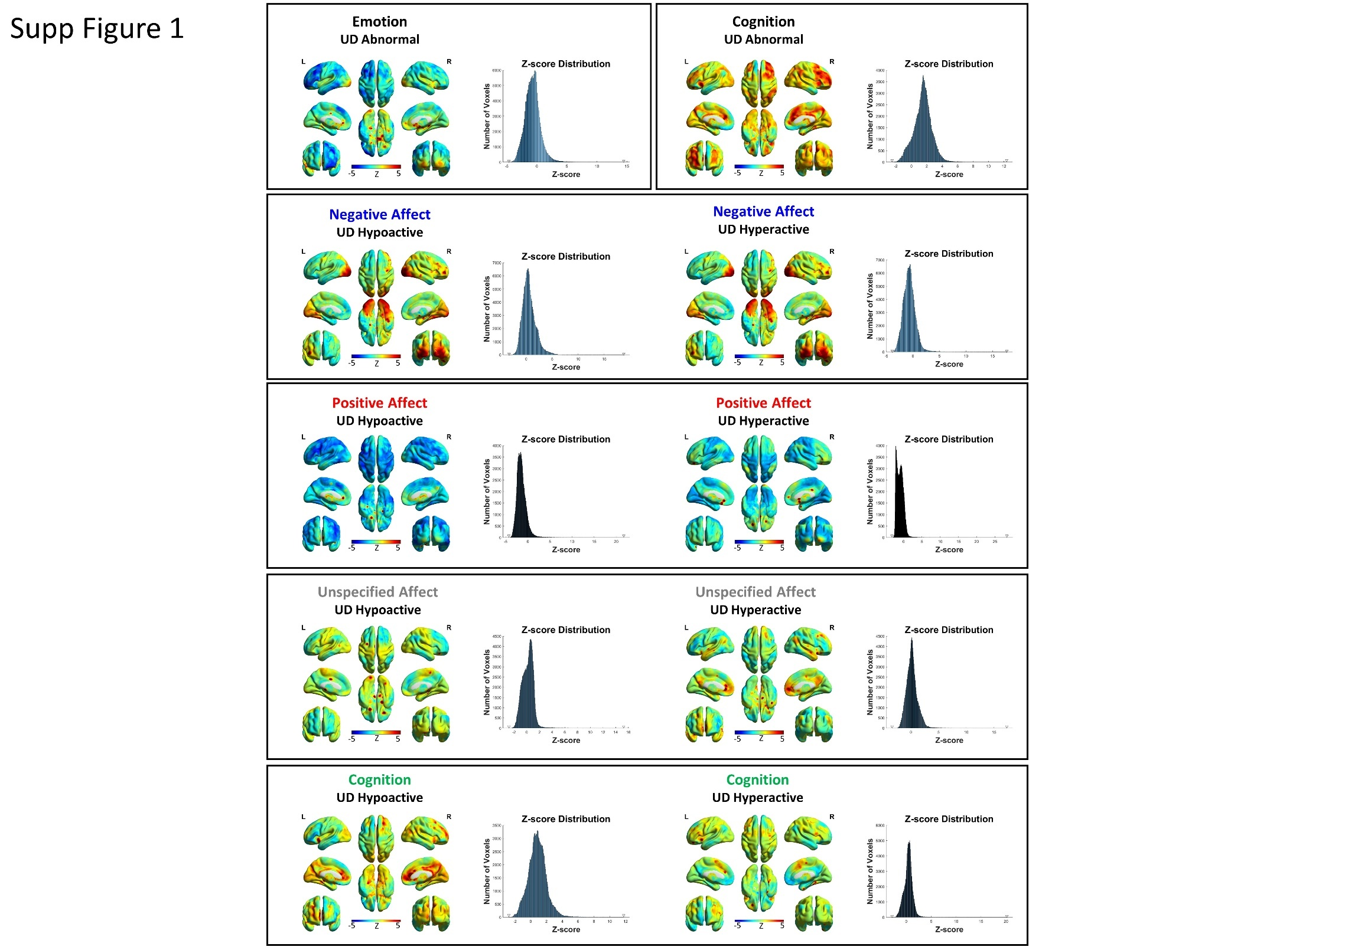

***Supplementary Figure 1: Circuits relating to aberrant hyper- and hypoactivity during emotional and cognitive tasks in UD.*** Brain connectivity is depicted for the coordinate sets related to abnormal brain function during emotional and cognitive tasks, including connectivity for subsets of coordinates relating specifically to aberrant hyper- and hypoactivity during emotional (negative, positive, and unspecified affect) and cognitive tasks. Note that for the emotion domain, these tasks refer to those testing (i) positive affect (e.g. fMRI response to viewing or processing ‘happy’ or positive emotional stimuli), (ii) negative affect (e.g. fMRI response to viewing or processing ‘sad’ or negative emotional stimuli), (iii) unspecified affect (i.e. when there was no clear designation as positive or negative affect). This designation of positive, negative and unspecified affect is derived from the original metanalysis1.The Z-score color-scale is held identical across all brain maps for consistency; however, this has the disadvantage of resulting in color saturation or alternatively only subtle color variation for some images. To assist in interpretation, the distribution of z-scores is depicted alongside each brainmap, with the minimum and maximum z-score indicated on the x-axis by an inverted triangle.

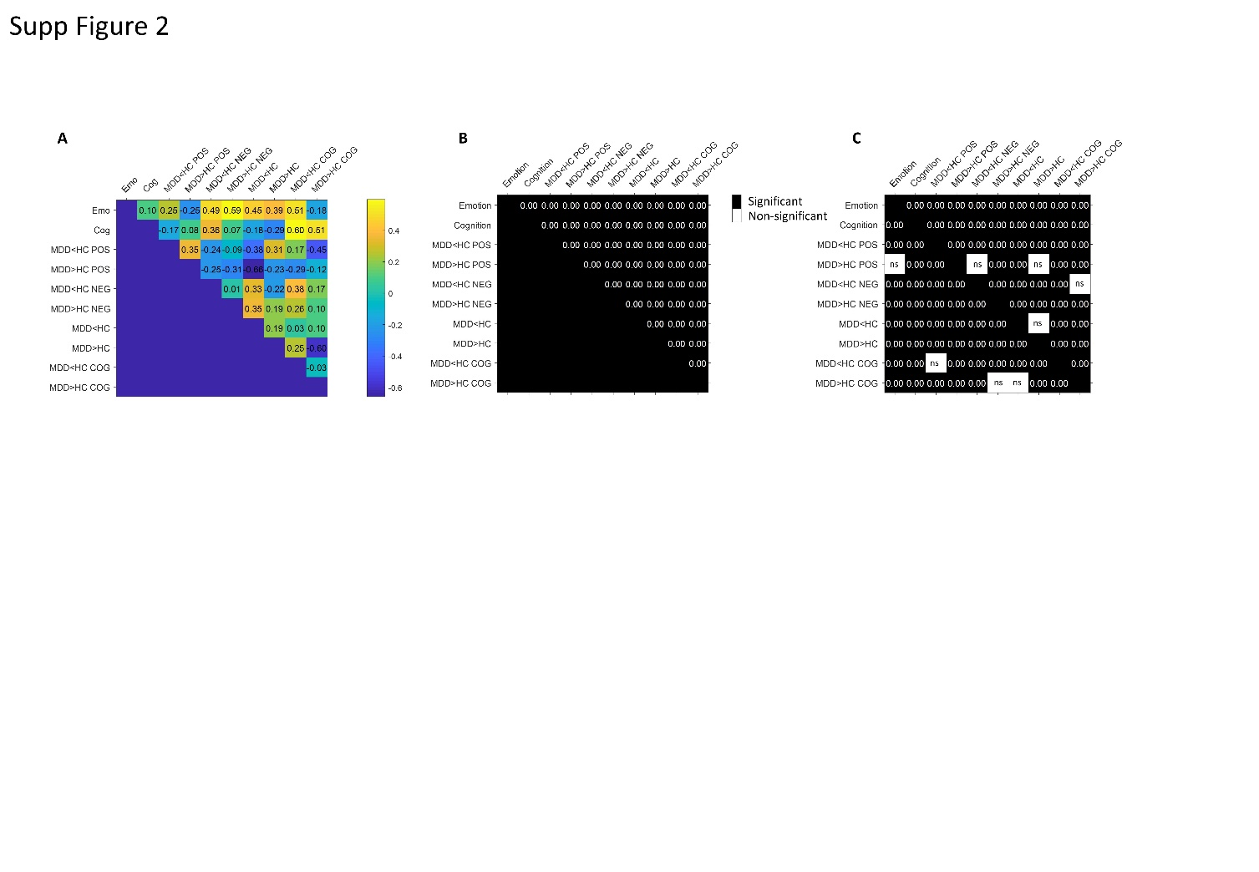

***Supplementary Figure 2: Correlograms on the relation between networks.*** **(A)** The whole-brain voxel-wise spatial correlation between brain circuits derived from emotional and cognitive tasks, and the related subcircuits is depicted. **(B)** Statistical significance is depicted for each two-tailed correlation, using a Bonferroni correction for multiple comparisons (45 comparisons), resulting in an alpha value of 0.001/45 = 0.00002. Non-/Significant correlations are depicted in white and black respectively. **(C)** Statistical significance is depicted for each correlation using a refined and stricter approach. For each row, 1000 brain maps were generated, each using an equivalent number of random coordinates. The spatial correlation of these 1000 brain maps with the brain map of interest was computed to determine a distribution of 1000 spatial correlation values, and subsequently, the probability that the spatial correlation between observed brain maps in a given row would occur by chance. Because this distribution is specific to any given (observed) brain map in each row, the procedure (distribution) was repeated one row at a time for each brain map of interest, resulting in an asymmetric matrix. A cut-off of alpha 0.001 was set to determine whether a spatial correlation was statistically significant relative to chance, i.e. relative to this distribution. Bonferroni correction was applied to all values to adjust for 90 comparisons, resulting in an alpha value of 0.001/90 = 0.00001. Non-/Significant correlations are depicted in white and black respectively.

***Supplementary Figure 3: Relation across different circuit models of depression.* (A)** Correlation between brain maps thresholded at an absolute z score ≥ 3. To ensure that the correlation was not biased by the number of voxels intersecting across thresholded brain maps, an asymmetric between-network correlation matrix was constructed. This involved thresholding only the first brain map in a pair, whilst the second brain map was held unthresholded. This procedure ensured that all voxels in the first brain map were available in the second brain map for the correlation computation. This procedure was repeated across each row of brain maps in the correlation matrix, with the brain map denoted in a given row always thresholded and the brain maps in columns unthresholded. To determine statistical significance, we employed a statistical procedure that more accurately computes the probability that the previously derived correlations would arise by chance. In short, when determining the statistical significance of the spatial correlation between two brain maps, the first brain map in the pair was first correlated with 1000 FC maps, derived from the random coordinates computed earlier, to generate a distribution of 1000 rho-values. The ‘observed’ rho-value was then compared to this distribution to generate a p-value. This procedure was employed such that the first brain map in the pair was that in the row, the second was in the column. Given that this statistical procedure generates an asymmetric matrix, the alpha value was Bonferroni corrected (0.001/20 = 0.00005). Statistical significance for autocorrelations is not depicted (redundant). **(B)** Secondary analysis depicting the correlation between brain maps when only the aberrant emotion and cognition maps were thresholded at an absolute z score ≥ 3, while other maps were not thresholded. The significance of correlations is depicted, thresholded at a Bonferroni corrected alpha value of (0.001/10 = 0.0001).

***Supplementary Figure 4:******Relation across circuit models of depression at different thresholds.*** Correlation between circuits using a range of thresholds whereby either the top 1.5, 5, 10, 15, 30, 50, 75% or all voxels of each map were retained prior to correlation and statistical analysis. Correlation coefficients were generally higher at more stringent thresholds, suggestive of stronger convergence within a more spatially specific circuit, and an advantage of thresholding out less relevant voxels which appear to contribute noise. For example, the spatial correlation between the lesion and convergent map and between the emotion and convergent map gradually decreased as more voxels are included. The cognition and lesion maps were more sensitive. The same statistical procedure described for Supplementary Figure 3A was employed.

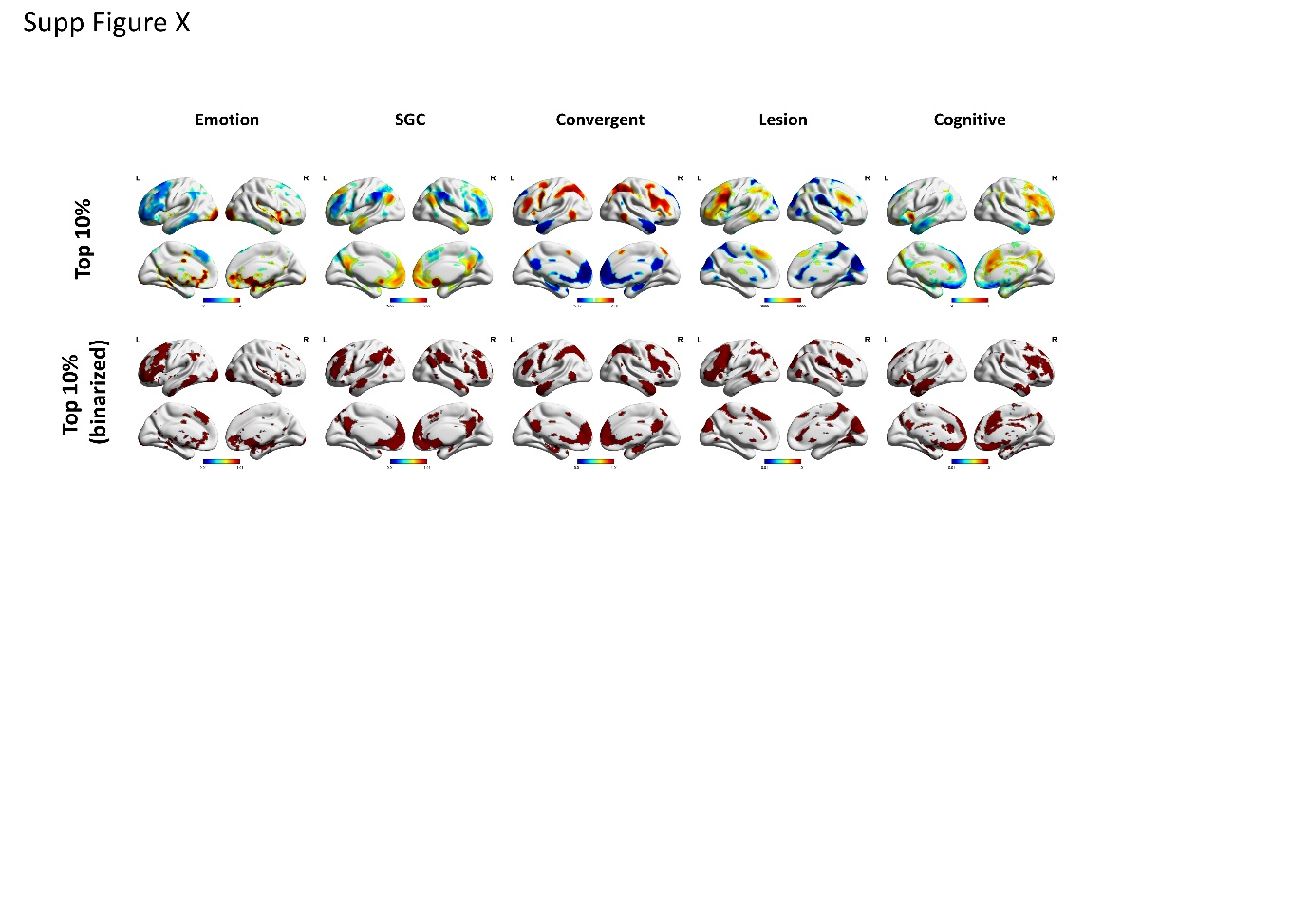

***Supplementary Figure 5: Spatial specificity and similarity across networks.***The emotion dysfunction network in UD derived from the present work closely recapitulates (i) the Subgenual Cingulate Cortex (SGC) whole-brain FC map that is closely associated with TMS therapeutic outcomes in depression 19-21, (ii) a depression circuit map that represents the FC of lesions that led to depression in previously healthy individuals 22, and (iii) a recently described ‘convergent depression circuit’ that incorporates the FC of lesion sites resulting in depression as well as the FC and efficacy of TMS cortical and DBS subcortical targets utilized in the treatment of depression 16. Note that TMS sites that improve depression are understood to be anticorrelated relative to DBS sites that improve depression58,59 or lesion sites associated with lower risk of depression16,22; the color scale could therefore alternatively have been inverted for the lesion and convergent maps to aid interpretation, but was left unchanged to ensure transparency. The cognitive dysfunction network in UD derived from the present work is more distinct from these circuits, potentially indicating specific dysfunction in this domain that is not captured as well by the other networks and could represent a separate and novel target for neuromodulation. The latter also appears to be more right lateralized. Each figure indicates the top 10% of most positive and negative z-scored values in the network.

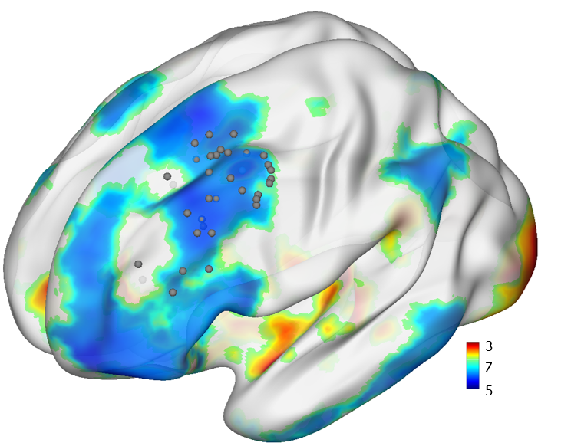

***Supplementary Figure 6: Position of optimal targets derived from the emotion dysfunction circuit.*** Each coordinate represents one participant. To facilitate illustration of how the coordinates relate to the network map, the emotion dysfunction circuit is thresholded to display the top 10% of most positive and negative z-scored values. The coordinates point to a more posterior site that is more in accordance with the target proposed by Siddiqi and colleagues (2021) relating to anxiosomatic symptoms.

**References**

1 Müller, V. I. *et al.* Altered brain activity in unipolar depression revisited: meta-analyses of neuroimaging studies. *JAMA psychiatry* **74**, 47-55 (2017).

2 Barch, D. M. & Pagliaccio, D. Consistency, replication, and meta-analyses of altered brain activity in unipolar depression. *JAMA psychiatry* **74**, 56-57 (2017).

3 Ioannidis, J. P., Fanelli, D., Dunne, D. D. & Goodman, S. N. Meta-research: evaluation and improvement of research methods and practices. *PLoS biology* **13**, e1002264 (2015).

4 Darby, R. R., Joutsa, J. & Fox, M. D. Network localization of heterogeneous neuroimaging findings. *Brain* **142**, 70-79 (2019).

5 Button, K. S. *et al.* Power failure: why small sample size undermines the reliability of neuroscience. *Nat Rev Neurosci* **14**, 365-376, doi:10.1038/nrn3475 (2013).

6 Poldrack, R. A. *et al.* Scanning the horizon: towards transparent and reproducible neuroimaging research. *Nat Rev Neurosci* **18**, 115-126, doi:10.1038/nrn.2016.167 (2017).

7 Carp, J. On the plurality of (methodological) worlds: estimating the analytic flexibility of FMRI experiments. *Frontiers in neuroscience* **6**, 149 (2012).

8 Marquand, A. F. *et al.* Conceptualizing mental disorders as deviations from normative functioning. *Molecular psychiatry* **24**, 1415-1424 (2019).

9 Molenberghs, P., Sale, M. V. & Mattingley, J. B. Is there a critical lesion site for unilateral spatial neglect? A meta-analysis using activation likelihood estimation. *Frontiers in Human Neuroscience* **6**, 78 (2012).

10 Fornito, A., Zalesky, A. & Breakspear, M. The connectomics of brain disorders. *Nat Rev Neurosci* **16**, 159-172, doi:10.1038/nrn3901 (2015).

11 Downar, J. & Daskalakis, Z. J. New targets for rTMS in depression: a review of convergent evidence. *Brain Stimul* **6**, 231-240, doi:10.1016/j.brs.2012.08.006 (2013).

12 Boes, A. D. *et al.* Network localization of neurological symptoms from focal brain lesions. *Brain* **138**, 3061-3075 (2015).

13 Siegel, J. S. *et al.* Disruptions of network connectivity predict impairment in multiple behavioral domains after stroke. *Proceedings of the National Academy of Sciences* **113**, E4367-E4376 (2016).

14 Padmanabhan, J. L. *et al.* A Human Depression Circuit Derived From Focal Brain Lesions. *Biol Psychiatry*, doi:10.1016/j.biopsych.2019.07.023 (2019).

15 Horn, A. The impact of modern-day neuroimaging on the field of deep brain stimulation. *Curr Opin Neurol* **32**, 511-520, doi:10.1097/WCO.0000000000000679 (2019).

16 Siddiqi, S. H. *et al.* Brain stimulation and brain lesions converge on common causal circuits in neuropsychiatric disease. *Nature Human Behaviour*, 1-10 (2021).

17 Baldermann, J. C. *et al.* Connectivity Profile Predictive of Effective Deep Brain Stimulation in Obsessive-Compulsive Disorder. *Biol Psychiatry* **85**, 735-743, doi:10.1016/j.biopsych.2018.12.019 (2019).

18 Eickhoff, S. B. *et al.* Behavior, sensitivity, and power of activation likelihood estimation characterized by massive empirical simulation. *Neuroimage* **137**, 70-85 (2016).

19 Cash, R. F., Cocchi, L., Lv, J., Fitzgerald, P. B. & Zalesky, A. Functional magnetic resonance imaging–guided personalization of transcranial magnetic stimulation treatment for depression. *JAMA psychiatry* **78**, 337-339 (2021).

20 Fox, M. D., Buckner, R. L., White, M. P., Greicius, M. D. & Pascual-Leone, A. Efficacy of transcranial magnetic stimulation targets for depression is related to intrinsic functional connectivity with the subgenual cingulate. *Biol Psychiatry* **72**, 595-603, doi:10.1016/j.biopsych.2012.04.028 (2012).

21 Weigand, A. *et al.* Prospective Validation That Subgenual Connectivity Predicts Antidepressant Efficacy of Transcranial Magnetic Stimulation Sites. *Biol Psychiatry* **84**, 28-37, doi:10.1016/j.biopsych.2017.10.028 (2018).

22 Padmanabhan, J. L. *et al.* A Human Depression Circuit Derived From Focal Brain Lesions. *Biol Psychiatry* **86**, 749-758, doi:10.1016/j.biopsych.2019.07.023 (2019).

23 Cash, R. F. *et al.* Personalized connectivity‐guided DLPFC‐TMS for depression: Advancing computational feasibility, precision and reproducibility. *Human brain mapping* **42**, 4155-4172 (2021).

24 Cash, R. F. *et al.* Personalized brain stimulation of memory networks. *Brain Stimulation* **15**, 1300-1304 (2022).

25 Fox, M. D., Liu, H. & Pascual-Leone, A. Identification of reproducible individualized targets for treatment of depression with TMS based on intrinsic connectivity. *Neuroimage* **66**, 151-160, doi:10.1016/j.neuroimage.2012.10.082 (2013).

26 Hamani, C. *et al.* The subcallosal cingulate gyrus in the context of major depression. *Biol Psychiatry* **69**, 301-308, doi:10.1016/j.biopsych.2010.09.034 (2011).

27 Groenewold, N. A., Opmeer, E. M., de Jonge, P., Aleman, A. & Costafreda, S. G. Emotional valence modulates brain functional abnormalities in depression: evidence from a meta-analysis of fMRI studies. *Neuroscience & Biobehavioral Reviews* **37**, 152-163 (2013).

28 Heilbronner, S. R., Safadi, Z. & Haber, S. N. Neurocircuits commonly involved in psychiatric disorders and their stimulation and lesion therapies. (2016).

29 Etkin, A., Egner, T. & Kalisch, R. Emotional processing in anterior cingulate and medial prefrontal cortex. *Trends in cognitive sciences* **15**, 85-93 (2011).

30 Wang, C. *et al.* Disrupted functional connectivity patterns of the insula subregions in drug-free major depressive disorder. *Journal of Affective Disorders* **234**, 297-304, doi:10.1016/j.jad.2017.12.033 (2018).

31 Sheline, Y. I., Price, J. L., Yan, Z. & Mintun, M. A. Resting-state functional MRI in depression unmasks increased connectivity between networks via the dorsal nexus. *Proc Natl Acad Sci U S A* **107**, 11020-11025, doi:10.1073/pnas.1000446107 (2010).

32 Downar, J. Orbitofrontal cortex: a ‘non-rewarding’new treatment target in depression? *Current Biology* **29**, R59-R62 (2019).

33 Bakker, N. *et al.* rTMS of the dorsomedial prefrontal cortex for major depression: safety, tolerability, effectiveness, and outcome predictors for 10 Hz versus intermittent theta-burst stimulation. *Brain Stimul* **8**, 208-215, doi:10.1016/j.brs.2014.11.002 (2015).

34 Binder, D. K. & Iskandar, B. J. Modern neurosurgery for psychiatric disorders. *Neurosurgery* **47**, 9-23 (2000).

35 Stockmeier, C. A. & Rajkowska, G. Cellular abnormalities in depression: evidence from postmortem brain tissue. *Dialogues in clinical neuroscience* **6**, 185 (2004).

36 Cash, R. F. H. *et al.* Using brain imaging to improve spatial targeting of TMS for depression. *Biological Psychiatry* **In Press** (2020).

37 Goodkind, M. *et al.* Identification of a common neurobiological substrate for mental illness. *JAMA psychiatry* **72**, 305-315 (2015).

38 Conradi, H., Ormel, J. & De Jonge, P. Presence of individual (residual) symptoms during depressive episodes and periods of remission: a 3-year prospective study. *Psychological medicine* **41**, 1165-1174 (2011).

39 Figee, M. & Mayberg, H. The future of personalized brain stimulation. *Nature Medicine* **27**, 196-197 (2021).

40 Li, B. J. *et al.* A brain network model for depression: From symptom understanding to disease intervention. *CNS neuroscience & therapeutics* **24**, 1004-1019 (2018).

41 Siddiqi, S. H. *et al.* Distinct symptom-specific treatment targets for circuit-based neuromodulation. *American Journal of Psychiatry* **177**, 435-446 (2020).

42 Gray, J. P., Müller, V. I., Eickhoff, S. B. & Fox, P. T. Multimodal abnormalities of brain structure and function in major depressive disorder: a meta-analysis of neuroimaging studies. *American Journal of Psychiatry* **177**, 422-434 (2020).

43 Wang, Q. *et al.* Normative vs. patient-specific brain connectivity in deep brain stimulation. *Neuroimage* **224**, 117307 (2021).

44 Smith, S. M. *et al.* Correspondence of the brain's functional architecture during activation and rest. *Proceedings of the national academy of sciences* **106**, 13040-13045 (2009).

45 Cole, M. W., Bassett, D. S., Power, J. D., Braver, T. S. & Petersen, S. E. Intrinsic and task-evoked network architectures of the human brain. *Neuron* **83**, 238-251 (2014).

46 Seeley, W. W. *et al.* Dissociable intrinsic connectivity networks for salience processing and executive control. *Journal of Neuroscience* **27**, 2349-2356 (2007).

47 Fox, M. D. & Raichle, M. E. Spontaneous fluctuations in brain activity observed with functional magnetic resonance imaging. *Nat Rev Neurosci* **8**, 700-711, doi:10.1038/nrn2201 (2007).

48 Vincent, J. L. *et al.* Intrinsic functional architecture in the anaesthetized monkey brain. *Nature* **447**, 83-86 (2007).

49 Glasser, M. F. *et al.* The minimal preprocessing pipelines for the Human Connectome Project. *Neuroimage* **80**, 105-124, doi:10.1016/j.neuroimage.2013.04.127 (2013).

50 Smith, S. M. *et al.* Resting-state fMRI in the Human Connectome Project. *Neuroimage* **80**, 144-168, doi:10.1016/j.neuroimage.2013.05.039 (2013).

51 Tian, Y., Margulies, D. S., Breakspear, M. & Zalesky, A. Topographic organization of the human subcortex unveiled with functional connectivity gradients. *Nature neuroscience* **23**, 1421-1432 (2020).

52 Birn, R. M. *et al.* The effect of scan length on the reliability of resting-state fMRI connectivity estimates. *Neuroimage* **83**, 550-558, doi:10.1016/j.neuroimage.2013.05.099 (2013).

53 Noble, S. *et al.* Influences on the Test–Retest Reliability of Functional Connectivity MRI and its Relationship with Behavioral Utility. *Cerebral Cortex* **27**, 5415-5429, doi:10.1093/cercor/bhx230 (2017).

54 Choe, A. S. *et al.* Reproducibility and temporal structure in weekly resting-state fMRI over a period of 3.5 years. *PloS one* **10**, e0140134 (2015).

55 Gordon, E. M. *et al.* Precision Functional Mapping of Individual Human Brains. *Neuron* **95**, 791-807 e797, doi:10.1016/j.neuron.2017.07.011 (2017).

56 Cui, Z. *et al.* Individual variation in functional topography of association networks in youth. *Neuron* **106**, 340-353. e348 (2020).

57 Coalson, T. S., Van Essen, D. C. & Glasser, M. F. The impact of traditional neuroimaging methods on the spatial localization of cortical areas. *Proc Natl Acad Sci U S A* **115**, E6356-E6365, doi:10.1073/pnas.1801582115 (2018).

58 Fox, M. D. *et al.* Resting-state networks link invasive and noninvasive brain stimulation across diverse psychiatric and neurological diseases. *Proc Natl Acad Sci U S A* **111**, E4367-4375, doi:10.1073/pnas.1405003111 (2014).

59 Fox, M. D. Mapping Symptoms to Brain Networks with the Human Connectome. *N Engl J Med* **379**, 2237-2245, doi:10.1056/NEJMra1706158 (2018).

60 Zalesky, A., Fornito, A. & Bullmore, E. T. Network-based statistic: identifying differences in brain networks. *Neuroimage* **53**, 1197-1207, doi:10.1016/j.neuroimage.2010.06.041 (2010).

61 Cash, R. F. H. *et al.* Subgenual Functional Connectivity Predicts Antidepressant Treatment Response to Transcranial Magnetic Stimulation: Independent Validation and Evaluation of Personalization. *Biological Psychiatry* **86**, e5-e7 (2019).

62 Fitzgerald, P. B., Hoy, K. E., Anderson, R. J. & Daskalakis, Z. J. A study of the pattern of response to rTMS treatment in depression. *Depress Anxiety* **33**, 746-753, doi:10.1002/da.22503 (2016).

63 Abbott, L. F. & Nelson, S. B. Synaptic plasticity: taming the beast. *Nat Neurosci* **3 Suppl**, 1178-1183, doi:10.1038/81453 (2000).

64 Fox, M. D., Halko, M. A., Eldaief, M. C. & Pascual-Leone, A. Measuring and manipulating brain connectivity with resting state functional connectivity magnetic resonance imaging (fcMRI) and transcranial magnetic stimulation (TMS). *Neuroimage* **62**, 2232-2243, doi:10.1016/j.neuroimage.2012.03.035 (2012).

65 Jenkinson, M., Beckmann, C. F., Behrens, T. E., Woolrich, M. W. & Smith, S. M. Fsl. *Neuroimage* **62**, 782-790 (2012).

66 Xia, M., Wang, J. & He, Y. BrainNet Viewer: a network visualization tool for human brain connectomics. *PloS one* **8**, e68910 (2013).

67 Beam, W., Borckardt, J. J., Reeves, S. T. & George, M. S. An efficient and accurate new method for locating the F3 position for prefrontal TMS applications. *Brain Stimulation* **2**, 50-54, doi:10.1016/j.brs.2008.09.006 (2009).